*Free software to open the*.gan files can be found here:*

[**http://www.ganttproject.biz**](http://www.ganttproject.biz/)

*There is a video tutorial here:*

[**https://www.youtube.com/watch?v=5rHCSa5ad34&feature=youtu.be**](https://www.youtube.com/watch?v=5rHCSa5ad34&feature=youtu.be)

You may need to fiddle in the Edit->Settings menu to set your software to the correct date format font size etc:

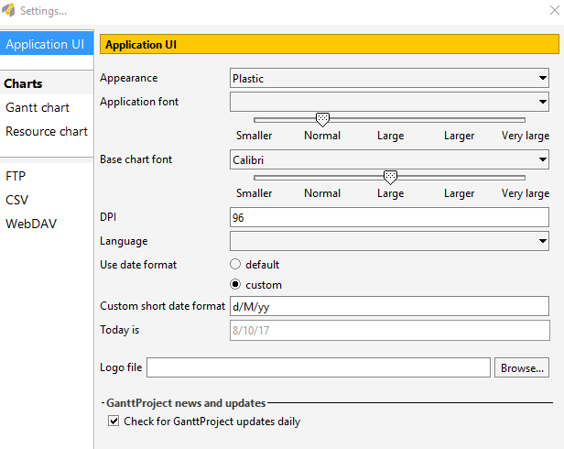

Click zoom in and out and drag the screen with the mouse to size the chart on screen:

